Project
‘Wairere’ at Pouakai New Plymouth NZ and ‘Te ara wairua: Pathway of the intangible’ at UCL, UK

Te Matahiapo Research Organisation, New Plymouth, NZ www.tematahiapo.org.nz

Stuart Foster and Kura Puke, Massey University, NZ
Haidy Geismar, UCL, UK

Concept

Display of a UK-based kākahu, bringing into light and presence through accessible virtual -visual technologies. This ceremonially-based experience will NZ community of origin to the kakahu and to create exchange/relationships between NZ and UCL guardian communities.
This mihi sets the course for this project that includes Northlodge UCL 19-30 June 2014 may include a proposed projection of the 3d scanned data of the cloak in an exhibition in NZ.

Key themes taonga, technology, the ‘intangible’, connection of people over distance.

Image Initial Sketch of Event One: UCL Octogon Gallery and Pouakai New Plymouth, 17 June 2014

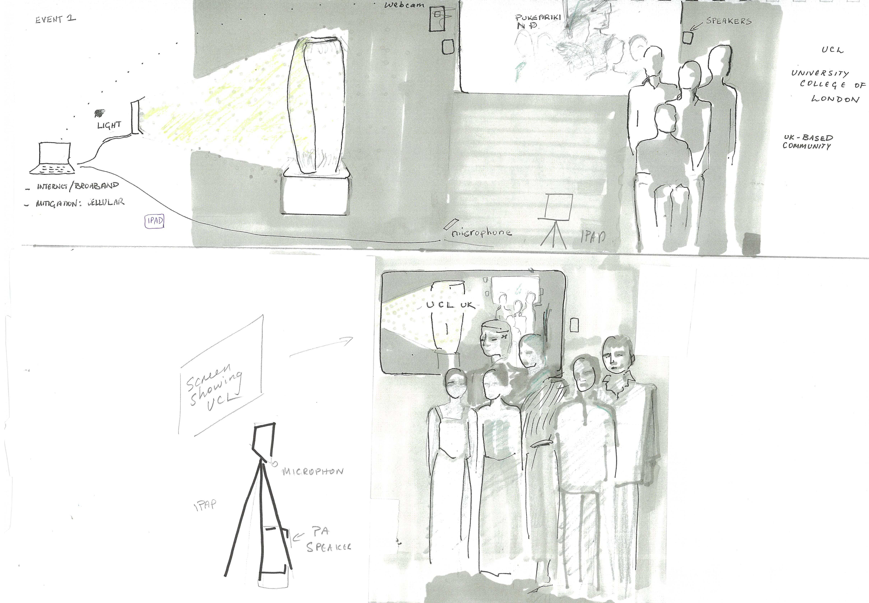

Event 1: June 17 ^{th} 2014

Real-time mihi from Western Institute of Technology (NP) to Octagon Gallery, UCL, London, UK.
When where

a] Pouakai New Plymouth, NZ Wednesday 8am 18 June 2014 and
b] University College of London, Octagon Gallery, Tuesday 9pm June 17 2014 http://www.ucl.ac.uk/museums/visit/highlights/octagon

- 8:00am New Zealand time at Pouakai (18th 8am)
- 9:00pm UK time at UCL: Octagon Gallery (17th 9pm)

duration at UCL : one hour 8:30-9:30pm

Attending at Pouakai

Dr. Te Huirangi Waikerepuru and Kuia Mere Broughton - our esteemed NZ kaumatua and Ahorangi o Te Matahiapo Research Organisation
Te Urutahi Waikerepuru Pouarahi o Te Matahiapo.

Attending at UCL

Stuart Foster, Kura Puke, Haidy Geismar (collaborators, UCl staff, Ngati Ranana…)
Ngati Ranana representatives to mihi to Taranaki

Description of mihi

A mihi will occur conducted by the above cultural experts, calling ‘into the light’ to the kakahu, through karanga, karaka, whaikorero (whakatuia); followed by greetings and exchange (whakatau) through to the whakanoa phase.

Each community will see and hear each other and the kakahu (exhibited at UCL)

The kaupapa is as follows:

The Taranaki community will call the cloak and the kakahu’s guardian communities.

UK time | Taranaki | UCL
 | Whakatakoto tuapapa
8:30pm |  | Brief on mihi process
 | Karanga: Te Urutahi Waikerepuru
9pm | Karanga : kuia Mere Broughton | Karanga : Ngati Ranana (contingency Kura Puke )
 | Karanga whakatau : kuia Mere Broughton
 | Whakatuia entrance into the space
 | Hongi: sharing the breath | Hongi sharing the breath
 | Whakatau active engagement
9:03 | 1st speaker karakia Dr Te Huirangi Waikerepuru
 | Mihi by Dr Huirangi Waikerepuru
9:08 |  | Reply speaker
Waiata (or after second Ngati Ranana speaker)
Virtual koha
9:13 | Koha reply Mere Broughton
 | Korero whakatau Dr Te Huirangi
 | Waiata
 | Karanga pea
 | Karanga pea
 | Korero Dr Te Huirangi english language | UK people English language
9:30pm | whakakapi
 | Karakia Naumai I nga hia..” Te Huirangi : may explain also in English
 | Refreshments | refreshments
Informal korero

Uk manuhiri mihi leaders
Ngāti Ranana
Maia Nuku maianuku@rocketmail.com
Regan O'callaghan reganocallaghan@gmail.com
Dean Sully d.sully@ucl.ac.uk
andrewmaina@gmail.com

Susi Pancaldo conservator Petrie Museum
Susi Chan
Dean Sully

Stuart Foster
s.t.foster@massey.ac.nz
stuartfoster@gmail.com
0044 7518409552 call from NZ
Facetime and skype (stuartfost)

Kura Puke
k.a.puke@massey.ac.nz
kurannpuke@gmail.com
0044 7518409551 call from NZ
Facetime and skype (kurapuke)

Te Urutahi Waikerepuru
027 7334662
teurutahi@tematahiapo.org
face time

Dr Haidy Geismar
h.geismar@ucl.ac.uk

Photographer: Charlie McKay (UK)
Mihi UK based NZ Assistants: Bonnie Field (Taranaki/Te Ati Awa) and Mickey Heath (UK)

Event 2: UCL Northlodge 19 June- 30 June 2014

The cloak is presented within a illuminated display case, that directs light onto the cloak, when sound is transmitted via broadband wireless from Aotearoa NZ. Sound (karanga, korero, environmental sounds, instruments). The quality of the sound directs qualities of the light projection, e.g. volume, pitch and timing may change the way the light is transmitted, creating different effects on the quality of the light.
Sound and the screened visual transmission can be live exchanges at specific dates. Sound can be recorded and played in a looped sequence for the duration of the exhibition interspersed with live event.

